# Overiview

* An UI element that enables the player to get a bird’s view of the level
* Helps the player in navigating around.

# Minimap

* A minimalist minimap will show the player a top down view of a part of the level around the player.
* The minimap will be a square shaped UI element.

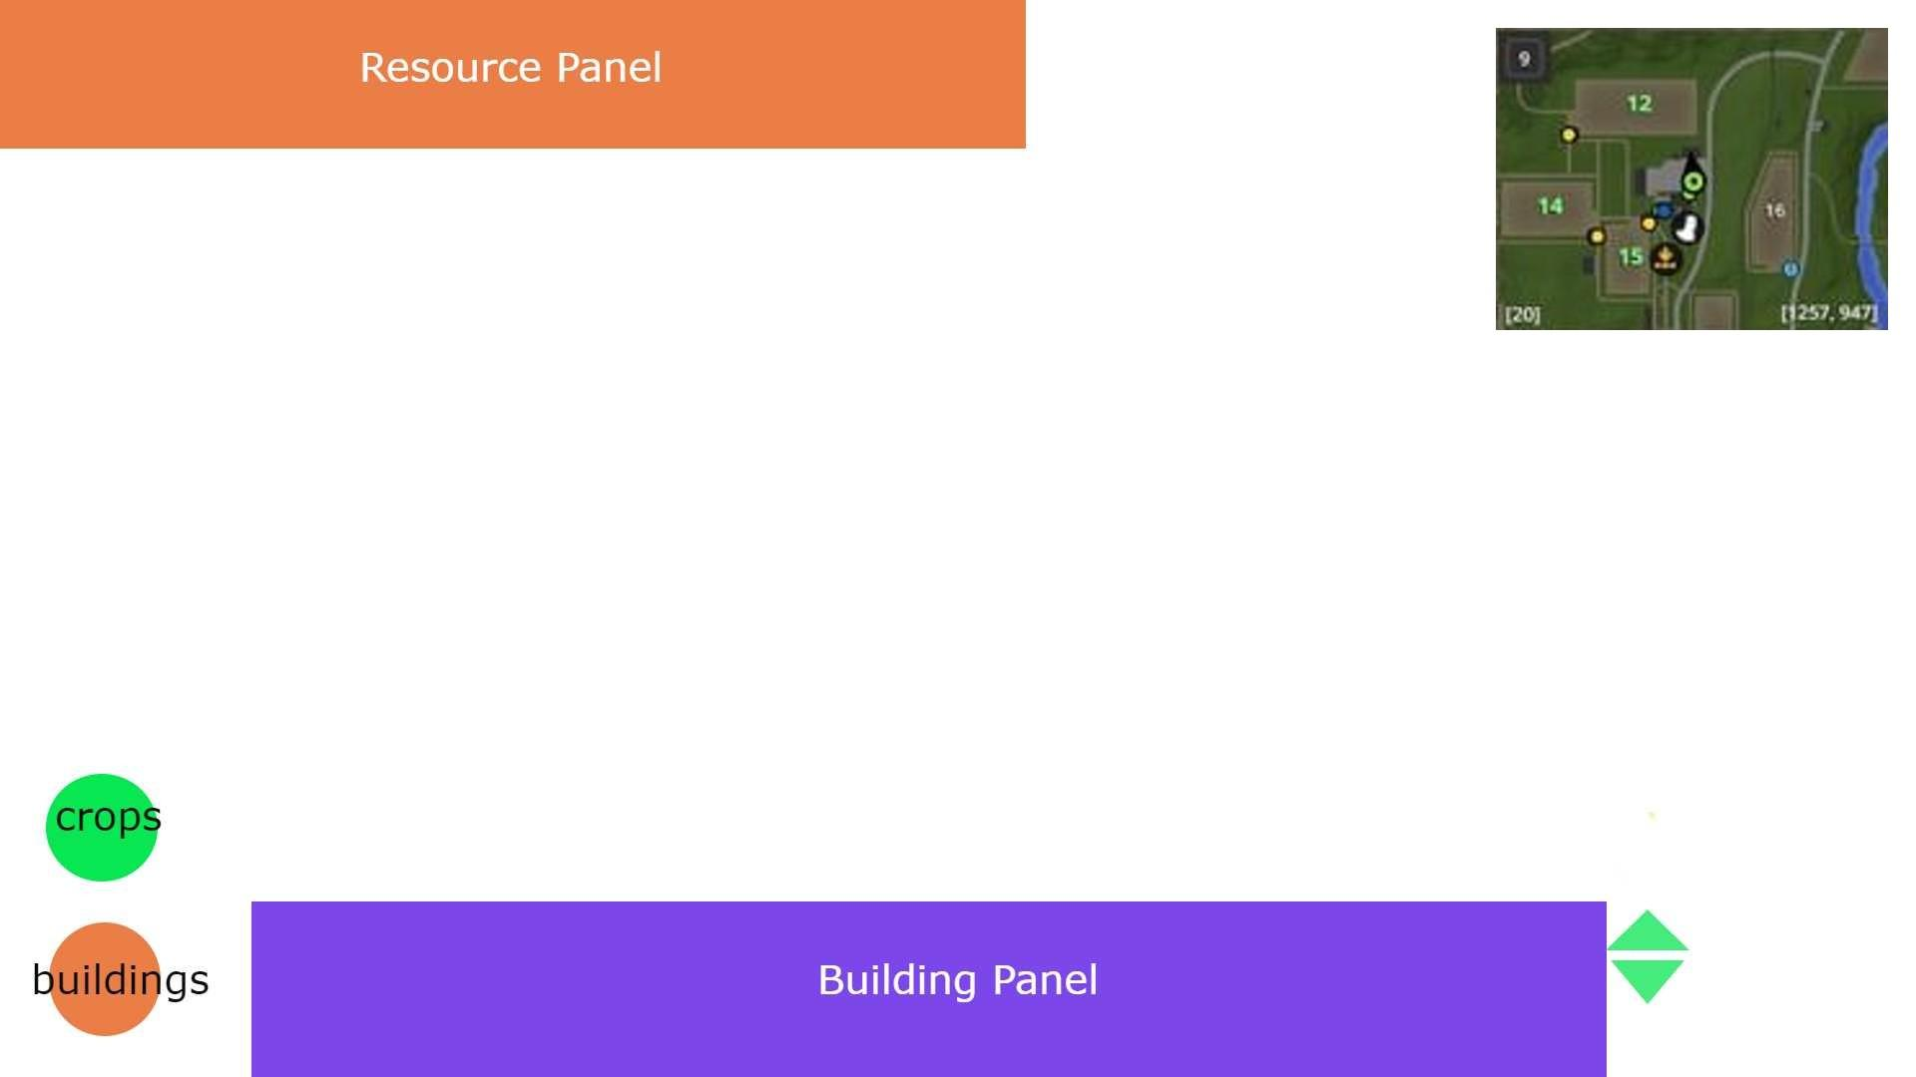

* Scaled down boundaries and shapes of farms, building, roads, water bodies, etc will be represented.
* The player’s position and forward direction will be showed with an inverted tear drop icon.
* The minimap updates as the players move.
* The minimap will also have alert notification icons for events like wildfire, pest attack,locusts, etc
* Long pressing “M” key will pop up a full map for the duration while the key is pressed.

